Name of the University : University of Calicut
Name of the P.O. NSS: Dr.Mujeeb Rahman P and Suregha P
NSS UNIT-17&107
Name of the College; Government of Arts and Science College, MEENCHANDA

Make up camp for second year

The activities of this year started with a one day makeup camp for second year students. The camp was organised in the college campus on 15th june 2019. Registration started at 8.am. After the drill session, it is inaugurated by the principal Dr. S. Jayasree, Govt.Arts and Science College, Calicut. She shared her thoughts and inspired the volunteers. A lecture on “The Involvement of students in society” is delivered by Mr. Sajin Jose, professional trainer. After the lunch prepared by the volunteers, campus cleaning took place. The camp dispersed at 5pm.

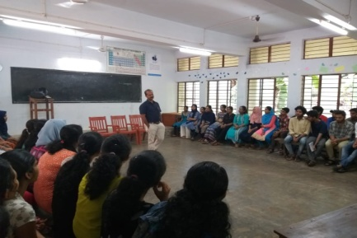 | 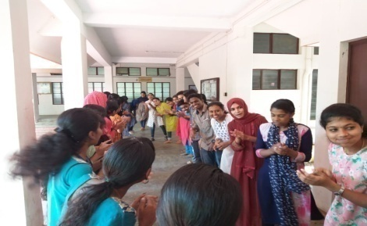
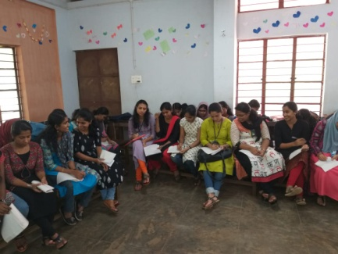 | 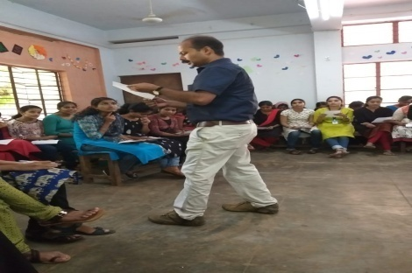

Anti-narcotic campaign

A One week long anti-narcotic campaign was organised in the campus in association with the antinarcotics cell and NCC. Anti-drug pledge was taken by the volunteers on 20th june 2019. And a photo exhibition was conducted in the campus on 28th june 2019. The campaign was inaugurated by VR Anil Kumar, deputy commissioner and a lecture was delivered by Dr.Sharath. Principal Dr. S. jayasree, Dr.Moncy Mathew, Dr.Muneer C P were present in the inaugural session.

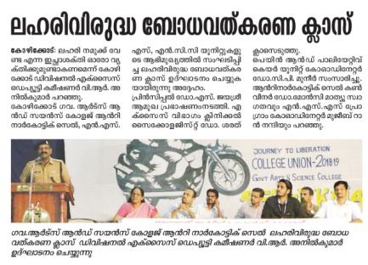 | 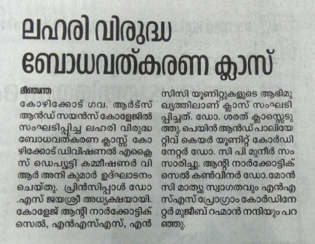
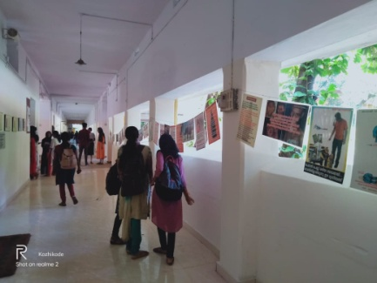 | 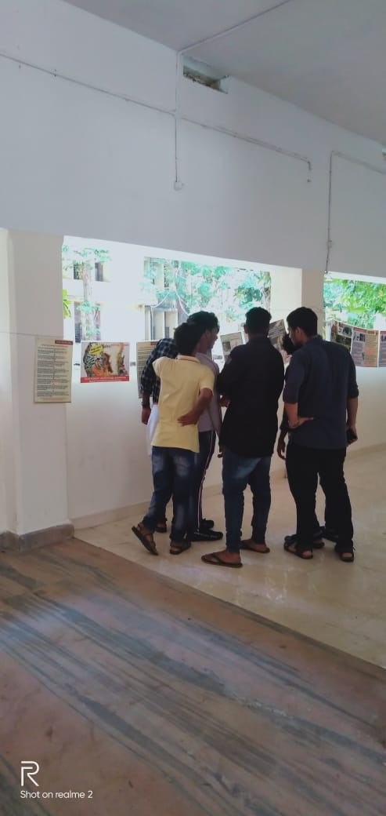

Vigilance awareness Programme

In association with Panjab National Bank, NSS units organised Vigilence Awareness programme in the campus. An essay competition for students was conducted on 2nd nov 2019.

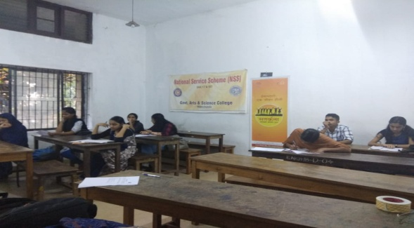

Eye test camp

As part of health awareness programme an Eye Test Camp and awareness class conducted for campus community on 29th and 30th October 2019. Around 600 inclusive of students and staff utilised this opportunity. It was organised in association with Mayo Clinic Kozhikode. Serious cases were referred to further check up.

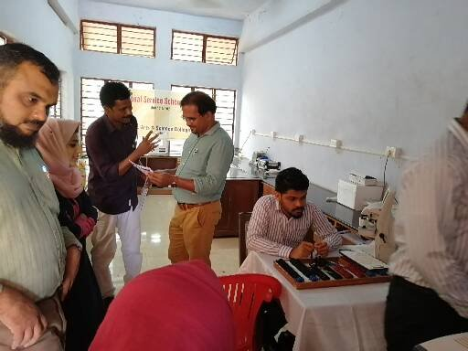 | 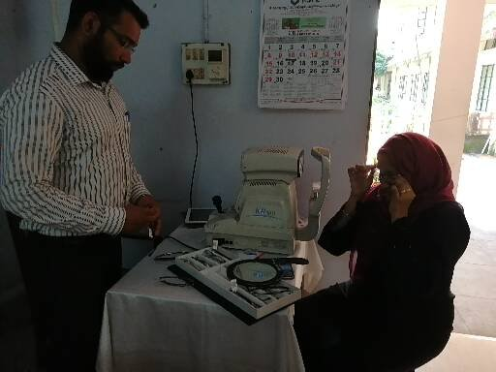
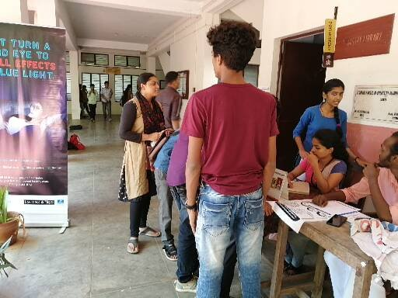 | 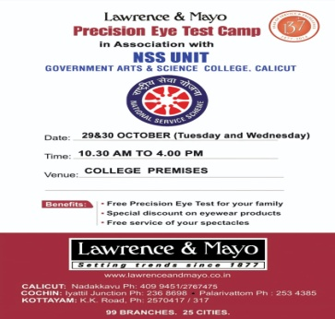

Note Book Sale

Buds School Ramanattukara is a school for children with special needs. They produce needful items like notebooks, dish wash, soap, etc. But the sales are really difficult for them. So our NSS units decided to extend them our hands. And that’s how we sold 1000 notebooks and gave them the full amount.

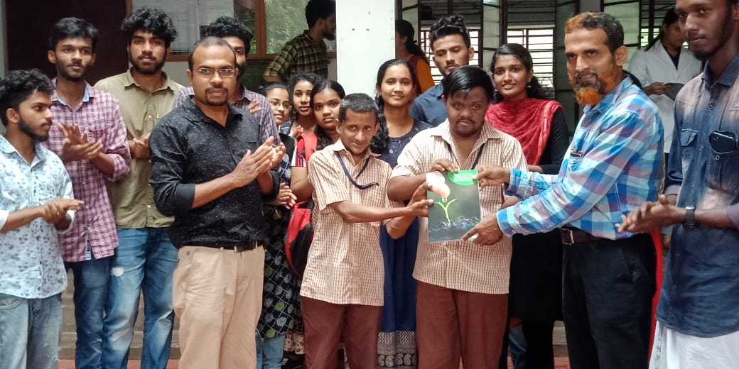 | 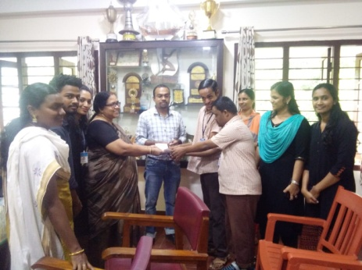

Poshan Abhiyan

In connection with nationwide programme, Poshan Abhiyan college NSS units organised a talk on Food Habits of Adolescence and Youth. Dr. Jithesh K, Senior consultant and General Physician, Meitra Hospital delivered an interesting talk. And many volunteers actively participated in the interactive
Session.

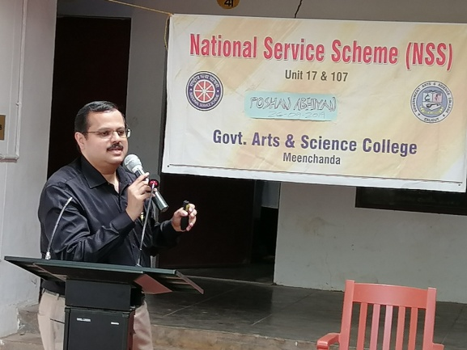 | 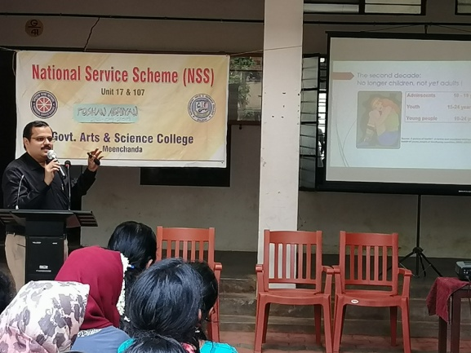
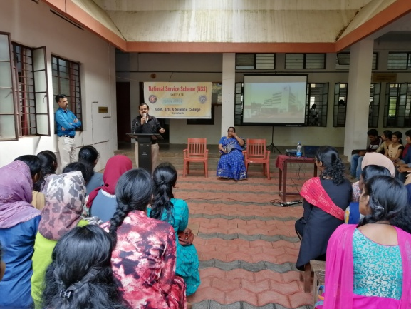 | 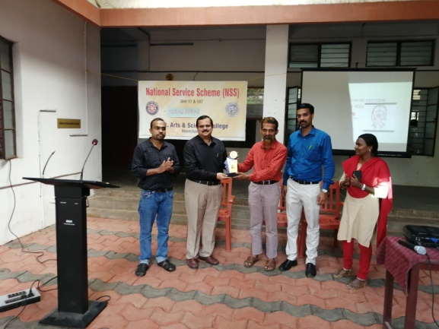

Beach Cleaning

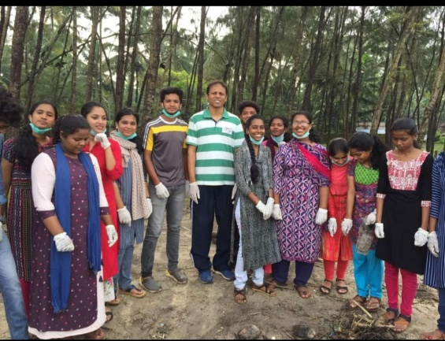 | 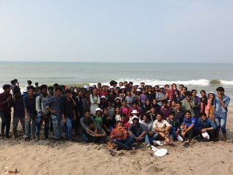
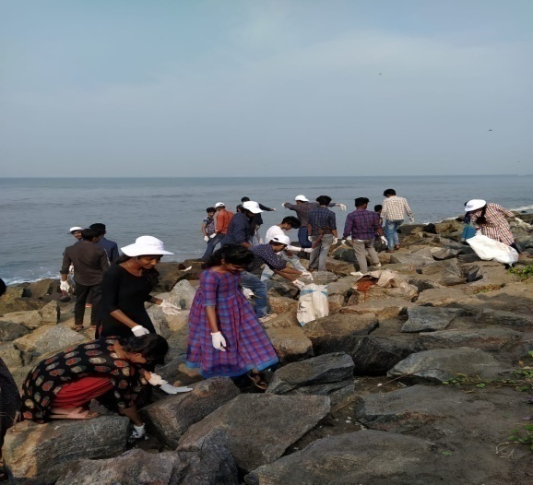 | 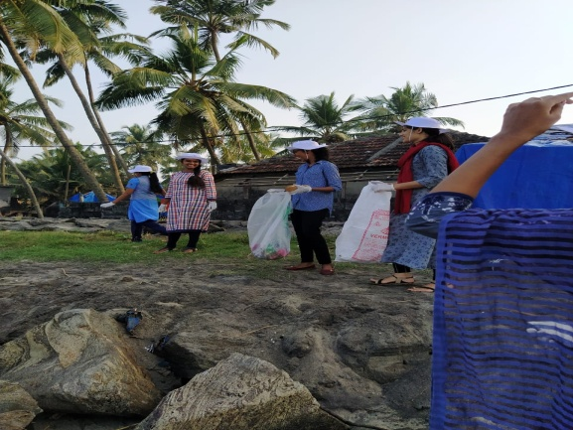

As part of District Administration Flagship Programme, “Clean Beach”, college NSS units joined hands with “Clean Beach” team and actively involved in the cleaning mission organised at Beypore, Kozhikode south and payyanakkal beaches. Our NSS units were specially recognised by the district authorities for our active involvement in the programme.

First year orientation camp

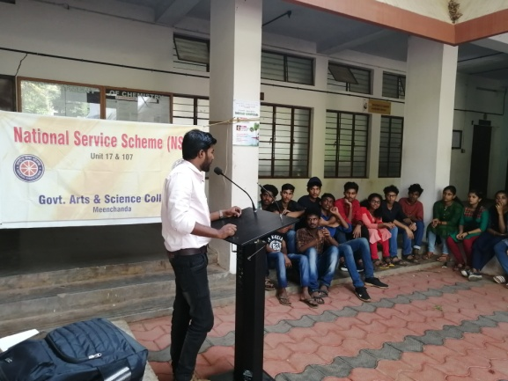 | 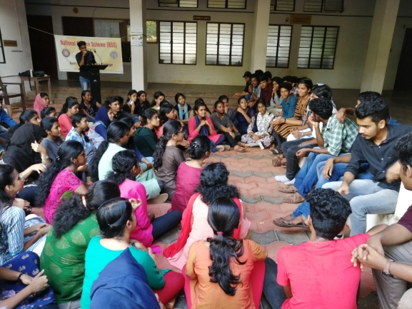
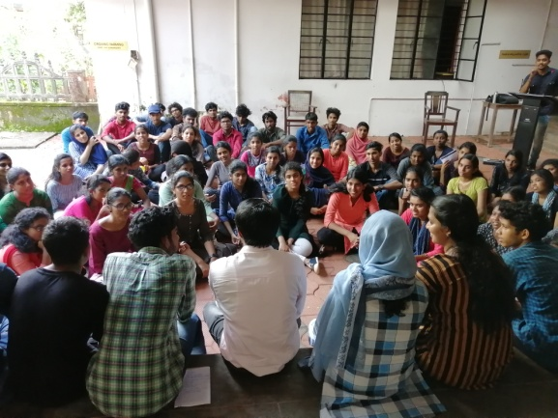 | 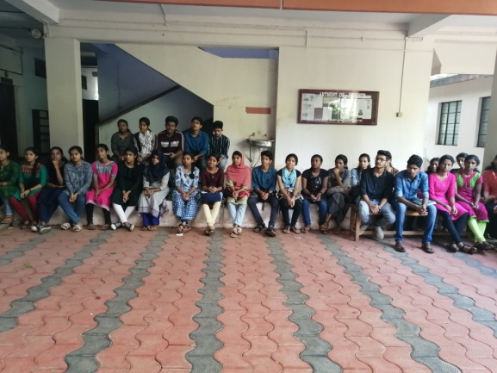

A one day camp was organised on 7 November 2019 for the newly selected vounteers. In the morning session vounteers joined with Mr. Nithin, department of Botany to set up a Botanical garden for the campus. After lunch, orientation class was handled by Mr. Viplavadas, Baithul Izza College, Narikkuni.

National award

Government Arts and Science College, Kozhikode NSS unit has proudly bagged Nation’s prestigious award for the best NSS Unit and Programme Officer for the academic year 2017-18. The unit is empowered with the vision of rendering democratic living and selfless service. The exemplary service of NSS volunteers and programme officers is recognised country-wide. And our NSS units conducted a programme in the campus to facilitate the winning of national award by Dr. Baby Sheeba, the best programme officer, Reja Fathima and Awsin, the best volunteers on 26th august2019. Principal Dr. S. jayasree, Dr.Munneer C P were present in the programme.

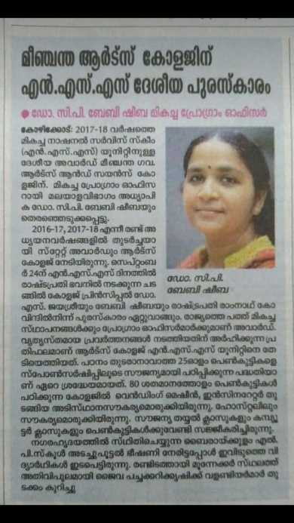 | 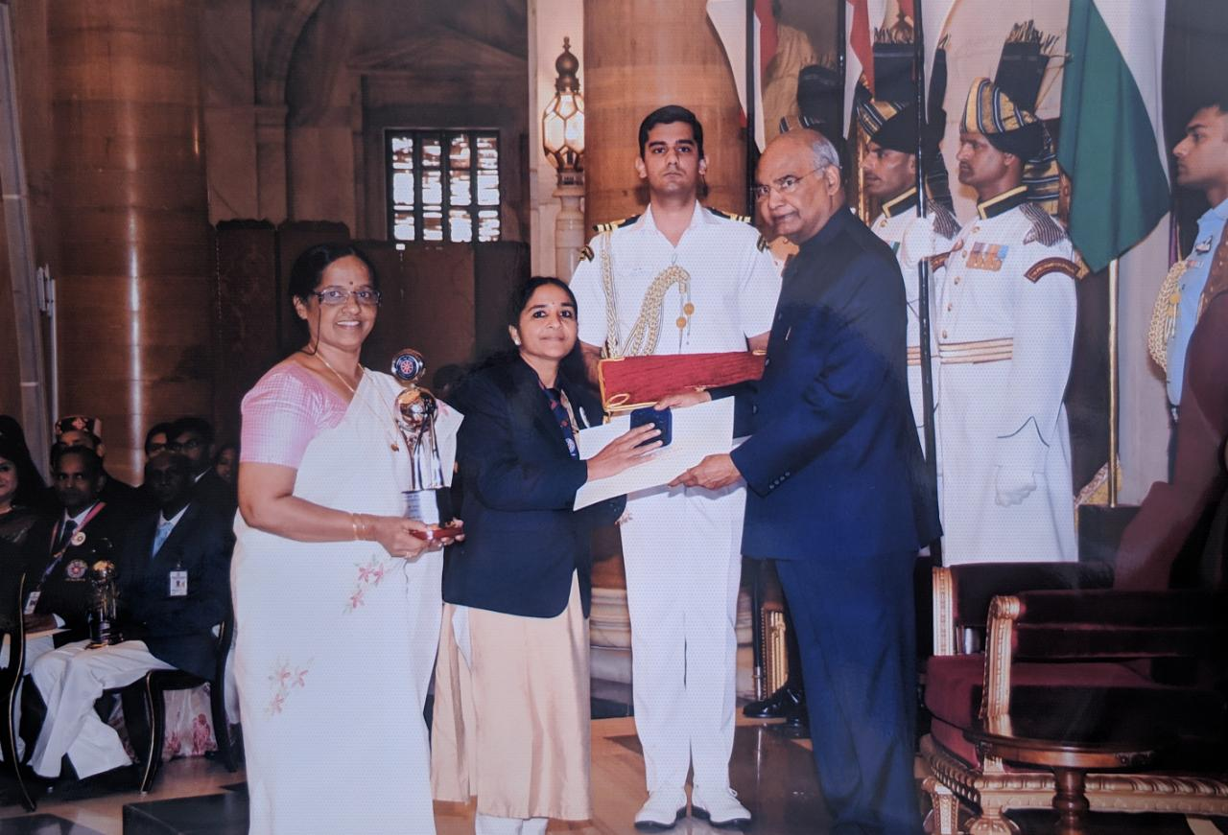
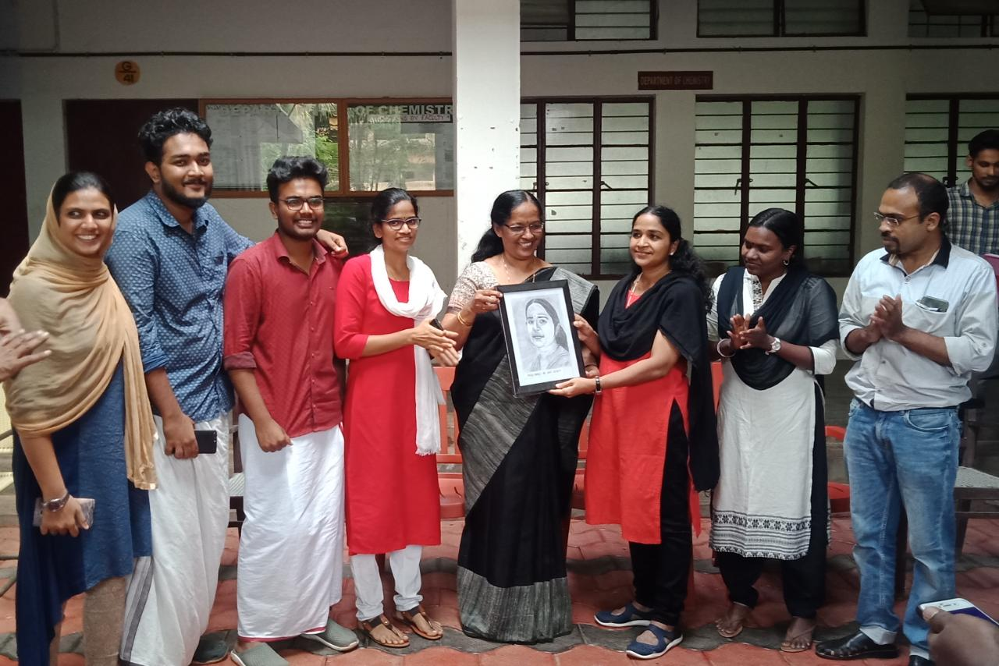 | 